5th Year

Dual Award

IGCSE CHEMISTRY

2010

Homework
Booklet

© Dr C R Lawrence

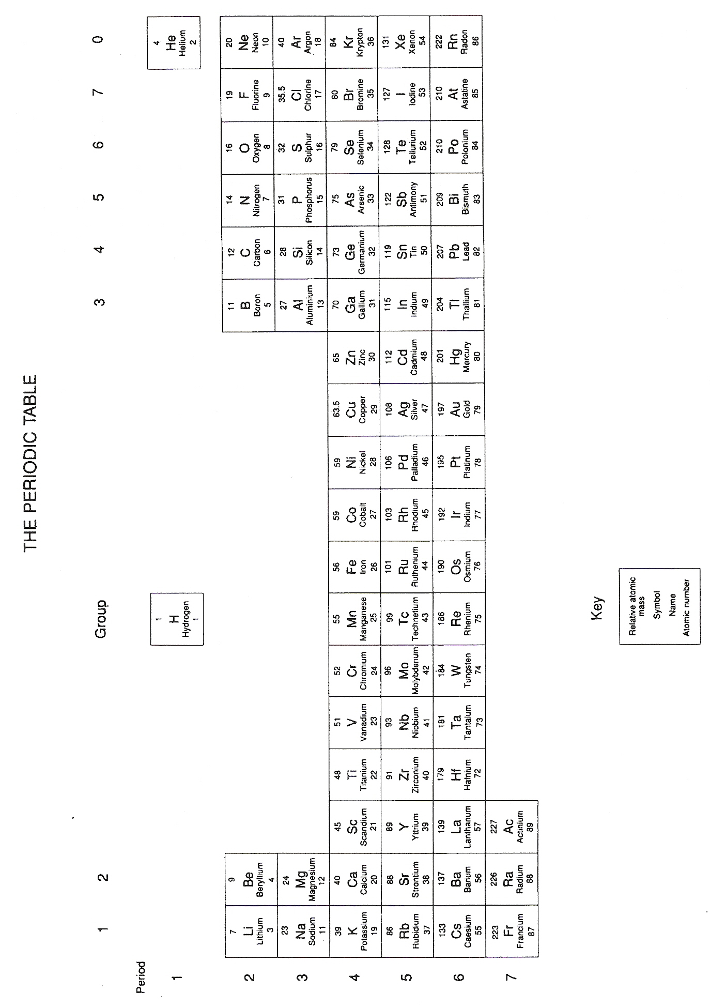

Homework | page
Making Salts 1 | 2
Making Salts 2 | 3
Moles and Concentration | 4
Methods of Salt Preparation | 5
Ionic Equations | 6
Identifying Gases and Cations | 7
Identifying Anions and Cations | 8
Getting off the island! | 9
Energy Changes | 10-11
Bond Energy Calculations | 13
Rates 1 – Surface Area | 14-15
Rates 2 - Concentration | 16-17
Rates 3 - Temperature | 19
Rates 4 – Curves and Catalysts | 20-21
Equilibria and The Haber Process | 22
Making Fertilisers | 23

Making salts 1
Complete Chemistry for IGCSE - pg 118-121 Total / 40

Copy and complete the table below to show the name of the salt formed when the following acids react with the following bases.
 | hydrochloric acid | sulphuric acid | nitric acid
sodium hydroxide
potassium carbonate
calcium
[5]

Write balanced symbol equations for the following reactions between some acids and some bases.

1) potassium hydroxide + sulphuric acid → [3]

2) nitric acid + sodium oxide → [3]

3) iron(II) carbonate + nitric acid → [3]

4) hydrochloric acid + aluminium → [3]

5) hydrochloric acid + barium hydroxide → [3]

6) iron + hydrochloric acid → [3]

7) nitric acid + lead(II) oxide → [3]

8) → copper sulphate + water + carbon dioxide [3]

9) → hydrogen + zinc nitrate [3]

10) copper(II) oxide + ………………… → copper(II) sulphate + ……………… [3]

11) Write an ionic equation for the neutralisation taking place in Qu 1) [2]

12) Write an ionic equation for the neutralisation taking place in Qu 2) [3]

Making Salts 2
Complete Chemistry for IGCSE - pg 116-121 Total / 30

1. Which ion must all acids contain? [1]

2 a) Write down the name and formula of two bases which contain copper. [2]

b) Write down the name and formula of two bases which contain zinc. [2]

3 a) Which acid and base would you choose to make sodium sulphate? [1]

b) Which acid and base would you choose to make calcium nitrate? [1]

c) Which acid and base would you choose to make barium chloride? [1]

4. Name two substances which could reacted (separately) with a suitable acid to make zinc chloride (by different reactions — not from acid + base). [2]

5. Complete and balance the following equations, adding state symbols:

a) CaCO₃ + HCl

b) Fe + HNO₃

c) Al(OH)₃ + H₂SO₄

d) KOH + H₃PO₄

e) Zn + Cu(NO₃)₂
[10]

6. Explain why copper sulphate cannot be made from the reaction between copper and sulphuric acid.
[2]

Independent Study

7. Describe what is meant by the following;
i) An acid using Arrhenius theory.
ii) A base using Arrhenius theory.
iii) An acid using Lowry/Bronsted theory.
iv) A base using Lowry/Bronsted theory. [4]

Challenge of the week

8. Comment on the following statement;
‘If you dilute a strong acid it will behave like a weak acid.’ [4]

Moles and Concentration
Complete Chemistry for IGCSE - pg 128-129 Total / 30

1 litre = 1 dm³ = 1000 cm³ (i.e. 100 cm³ = 0.1 dm³ , and 10 cm³ = 0.01 dm³ )

1. Find how many moles of dissolved solute there are in the following volumes:
(a) 20 cm³ of a solution of NaOH containing 2.40 mol dm⁻³ [1]
(b) 400 cm³ of a solution of HCl containing 0.500 mol dm⁻³ [1]
(c) 5000 cm³ of a solution of H₂SO₄ containing 0.0200 mol dm⁻³ [1]

2. What is the concentration of a solution in which:
- 0.2 mol NaOH is dissolved in 200 cm³ water? [1]
- 4 mol HCl is dissolved in 1800 cm³ of water? [1]

3. What mass of solid is dissolved in:
a) 50 cm³ of a solution containing 4.6 mol dm⁻³ of K₂SO₄ [2]
b) 400 cm³ of a solution of HCl containing 2.4 mol dm⁻³? [2]

4. a) Determine the concentration of 224g of KOH dissolved in 2000 cm³ of water. [2]
b) What mass of silver nitrate (AgNO₃) would be required to give 250 cm³ of a solution
of concentration 0.5 mol dm⁻³? [2]

5. Potassium hydroxide reacts with sulphuric acid according to the equation:
20 cm³ of a solution of sulphuric acid of concentration 0.8 mol dm⁻³ needs 25 cm³ of a solution of
potassium hydroxide to neutralise it completely.
Find the concentration of the KOH solution, in mol dm⁻³, by means of the following steps:
(a) How many moles of acid are there in 20 cm³ of sulphuric acid? [1]
(b) How many moles of KOH are needed to react with this amount of sulphuric acid? [1]
(c) This number of moles of KOH must have been dissolved in 25 cm³ of water, so how many
moles are dissolved in 1 dm³? This is the concentration. [1]

6. A drain cleaner contains sodium hydroxide solution.
In a titration experiment, the sodium hydroxide in a 25.0 cm³ sample of the drain cleaner was
neutralised by 20.0 cm³ of hydrochloric acid.
The concentration of the hydrochloric acid was 0.5 mol dm⁻³.
The equation for the reaction is: NaOH + HCl → NaCl + H₂O

a) Describe, giving the names of the apparatus used, how the titration is carried out. [4]
b) Calculate the concentration in mol dm⁻³ of sodium hydroxide in the drain cleaner. [3]
c) Calculate the mass of sodium hydroxide in a bottle containing 250 cm³ of this drain cleaner. [3]

Challenge of the week

7. In an experiment it was found that exactly 12.5 cm³ of sodium hydroxide which had a concentration of 1.75 mol dm⁻³ was required to neutralise 20 cm³ of sulphuric acid.
Find the concentration of the sulphuric acid. [4]
Methods of Salt Preparation
Total / 40

Read pages pg 124-127 in your textbook - Complete Chemistry for IGCSE.

1) Answer Questions 1 to 6 on page 125. [12]

2) Answer Questions 1 to 3 on page 127. [9]

3) Identify the precipitate formed in the following reactions.

a. Zinc sulphate + Lead(II) nitrate → Zinc nitrate + Lead sulphate

b. Barium chloride + Sodium carbonate → Barium carbonate + Sodium chloride

c. Lead(II) nitrate + Lithium sulphate → Lead(II) sulphate + Lithium nitrate

d. Potassium bromide + Silver nitrate → Silver bromide + Potassium nitrate. [4]

4) Write balanced ionic equations for the formation of the precipitates in question 2. [8]

5) Describe, with the aid of diagrams, how you would prepare a sample of;
  - Lead nitrate (a soluble salt), [4]

  - Lead chloride (an insoluble salt). [3]
Ionic Equations
Complete Chemistry for IGCSE - pg 120-121 and 124-127 Total / 32

1. A solubility table is given below.
soluble | insoluble
sodium, potassium and ammonium  salts | silver chloride and lead chloride
nitrate salts | lead sulphate, barium sulphate and  calcium sulphate

a) A very small sample of a salt is placed in a boiling tube.
The tube is half filled with water and then shaken vigorously.
The tube is then left for five minutes.
Describe what you would see if the salt is:
(i) lead sulphate [1]
(ii) ammonium chloride [1]

b) You have been asked to prepare lead chloride from lead nitrate and sodium chloride.
(i) Explain how you would prepare a pure, dry sample of the salt from the solutions. [4]
(ii) Write a balanced equation for the reaction (including state symbols).
(Lead has a valency of 2) [3]
(iii) Write a balanced ionic equation for the reaction (including state symbols). [2]
(iv) Why could you not use a similar method to prepare sodium sulphate? [1]

2. Write out BALANCED symbol and ionic equations for the following.

a. Barium + hydrochloric acid → barium chloride + hydrogen [4]

b. Aluminium oxide+ sulphuric acid → aluminium sulphate + water [4]

c. Barium hydroxide + nitric acid → barium nitrate + water [4]

d. Magnesium carbonate + nitric acid → magnesium nitrate + water + carbon dioxide [4]

e. Sodium carbonate + hydrochloric acid → sodium chloride + water + carbon dioxide [4]

Identifying Gases and Cations
Complete Chemistry for IGCSE - pg 288-291 Total / 30

1. Name the gas which
(i) relights a glowing splint
(ii) turns damp red litmus paper blue
(iii) turns blue cobalt chloride pink
(iv) gives a squeaky pop when ignited [4]

2. Describe a test to show the presence of ammonium ions in ammonium chloride. [4]

Challenge of the week
3. You find yourself abandoned on a desert island. One the sea shore you find a package containing a set of unlabelled chemical solids, a bunsen burner, a gas supply, nichrome wire and some hydrochloric acid along with a note. The note states that you will only be rescued if you can identify all of the solids. Luckily your potential rescuers have included a list of the solids you need to identify. They are;
potassium chloride,
potassium carbonate,
sodium nitrate,
sodium hydroxide,
lithium sulphate,
copper chloride,
iron(II) sulphate,
iron(III) iodide,
and sugar.
A small amount of toxic material has been added to all the solids except for the sugar.
You will die if you drink them. (No animals or plants must be harmed in your experiments).

- Describe chemical tests that could be done to identify all the solids and so enable you to determine which drum contains the sugar needed for a nice cup of tea. [10]

- Write balanced chemical equations for three of the reactions you have chosen. [6]

- Write ionic equations for the three reactions in part b. [6]

Time for nice cup of tea. (Two sugars please!)

Identifying Anions and Cations
Complete Chemistry for IGCSE - pg 288-291 and RGS infonet notes Total / 48

1 a) Some aqueous iron(II) sulphate is divided into two samples
i) To the first portion aqueous sodium hydroxide is added.
State what you would see and write an overall and an ionic equation for the reaction. [4]

ii) To the second portion a mixture of dilute hydrochloric acid and aqueous barium chloride
were added.
State what you would see and write an overall and an ionic equation for the reaction. [4]

b) A solution sold as fertiliser for household plants is thought to contain both potassium ions and
ammonium ions. Describe the tests which you would carry out to decide if this were so. [4]

2. A mixture A contains two compounds.
- On shaking A with water a pale blue solution B and a colourless solution C are obtained.
- On adding aqueous sodium hydroxide solution to B, a pale blue precipitate D and a colourless solution E are produced.
- On adding a mixture of dilute nitric acid and aqueous silver nitrate to E a white precipitate F and a colourless solution G are produced.
- Solution C reacts with dilute hydrochloric acid to produce a colourless solution H and a colourless gas I which turns limewater milky.
- On adding aqueous sodium hydroxide to H a pugent gas J is produced which turns damp red litmus blue.
- On adding excess dilute sulphuric acid to gas J a colourless solution K is produced.

Identify the substances A to K giving your reasoning. [20]

Challenge of the week.
3. You have managed to survive on the desert island for a week. However, you are running low on
pure water. Luckily you have a new chemistry set containing the normal lab chemicals and glassware. You also have some unlabelled 5 gallon drums that are known to contain the following; Uranium sulphate, Uranium chloride, Uranium iodide, Uranium carbonate and water. Uranium salts are very toxic and you will die if you drink them.
(No animals or plants must be harmed in your experiments).

- Describe chemical tests that could be done to identify all the chemicals and so enable you to determine which drum contains the water you need to survive. [8]
- Write balanced chemical equations for two of the reactions you have chosen.
(Assume Uranium has a valency of 2) [6]
- What simple physical test could be done to identify the drum containing water. [2]

Getting off the island!
Complete Chemistry for IGCSE - pg 288-291 and RGS infonet notes Total / 35

You have managed to survive on the desert island for yet another week. One the sea shore you find a package containing a set of unlabelled chemical solids along with a note. The note states that you will only be rescued if you can identify all of the ten solids. Luckily your potential rescuers have included a list of the solids you need to identify. They are potassium chloride, potassium sulphate, potassium carbonate, copper sulphate, copper carbonate, copper chloride, barium iodide, barium carbonate, barium sulphate and sugar.

Describe chemical tests that could be done to identify all the solids.

Energy Changes
Complete Chemistry for IGCSE - pg 160-165. Total / 27

1. When 1g of ethanol undergoes complete combustion, 29.8 kJ of heat energy is given out.
How much heat would be given out one mole of ethanol? [3]

2. Draw an energy level diagram to show the energy change in Qu 1. [3]

3. When sulphur is burnt in oxygen it forms sulphur dioxide.
S + O2 → SO2 energy change = -297 kJ/mol
Calculate the heat given out when 1.6 g of sulphur is burnt. [4]

4. This equation shows the reaction between ethene and oxygen.
C2H4 + 3O2 → 2CO2 + 2H2O
The structural formulae in the equation below show the bonds in each molecule involved.
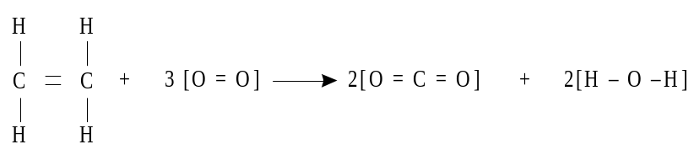
Use the three stages shown at (a), (b) and (c) below to calculate the nett energy transfer when the
formula mass (1 mole) of ethene reacts with oxygen.

(a) Write down the bonds broken and the bonds formed during the reaction.
(Some have already been done for you.)
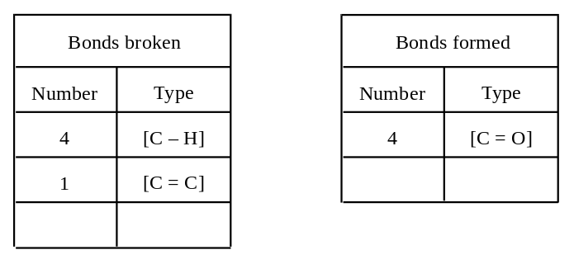 [2]
(b) Calculate the total energy changes involved in breaking and in forming all of these bonds.
(Some have already been done for you.)
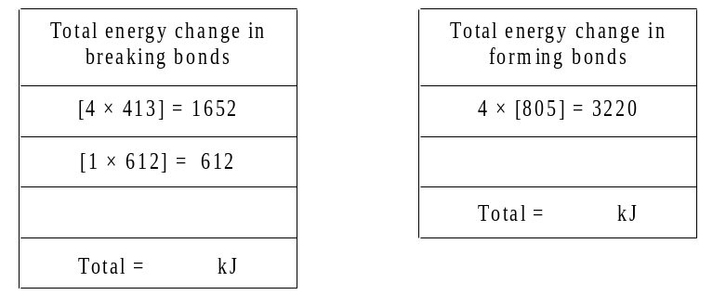 [2]
(c) Describe, as fully as you can, what the figures in (b) tell you about the overall reaction. [2]
5. The symbol equation shows the decomposition of water. 2H2O → 2H2 + O2
An energy level diagram for this reaction is shown below.
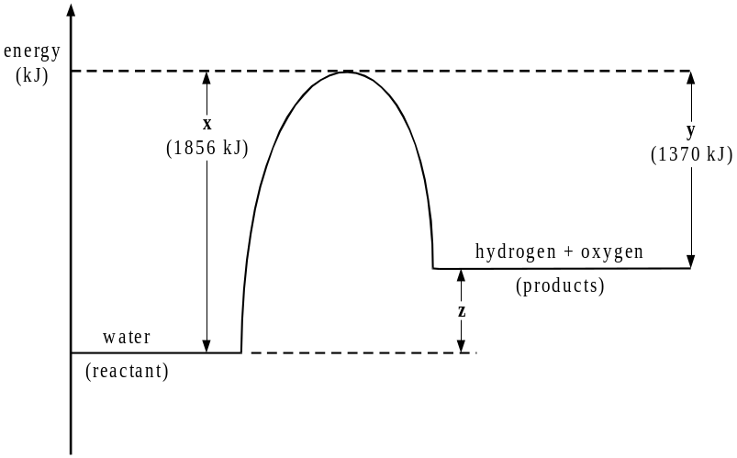
Explain the significance of x, y and z on the energy level diagram in terms of energy transfers that occur in the reaction.
You should make specific reference to the bonds broken and formed and to the net energy transfer (energy transferred to or from the surroundings). [6]

6. An energy diagram is shown below for the slaking of calcium oxide.

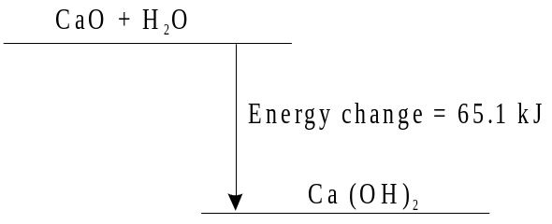

(i) Explain what the diagram tells you about the energy change which takes place in this reaction.
[2]
(ii) Explain fully what the diagram tells you about the relative amount of energy required to break bonds and form new bonds in this reaction.
[3]

Bond Energy Calculations
Complete Chemistry for IGCSE - pg 162-163. Total / 30

 | bond | bond energy (kJ/mol) |  | bond | bond energy (kJ/mol)
 | H-H | 436 |  | C=O | 743
 | O=O | 496 |  | H-O | 463
 | C-C | 348 |  | Br-Br | 193
 | C=C | 612 |  | C-Br | 276
 | C-H | 412 |  | H-Br | 366
 | N≡N | 944 |  | N-H | 388
 | C-N | 305 |  | N-N | 158
 | C-O | 360

1) a) Use the bond energy data in the table to calculate the energy change in each reaction below
(make sure your sign is correct). [24]

i) | 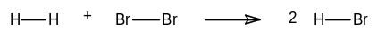
ii) | 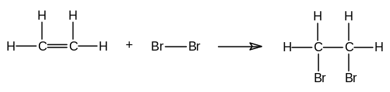
iii) | 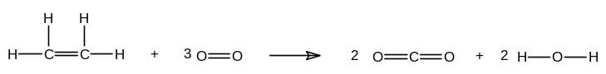
iv) | 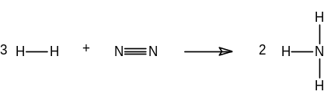
v) | 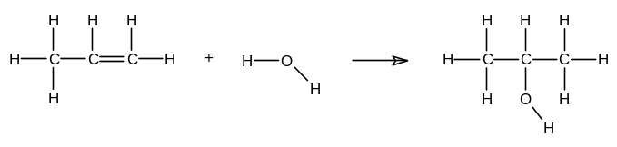
vi) | 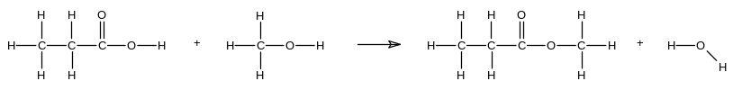
b) Draw an energy profile diagram to show the relative position of the reactants and products in for one of the reactions iv). [2]

Challenge of the week
2) a) The energy change for the following reaction is +1646 kJ/mol. CH₄ → C + 4H
Use this information to find the average C-H bond energy. [2]

- A similar reaction involving ethane (C₂H₆) has an energy change of +2826 kJ/mol.
C₂H₆ → 2C + 6H
Use this and your answer to (a) to calculate the value of the C-C bond energy in ethane. [2]
Rates 1 - Surface Area
Complete Chemistry for IGCSE - pg 144-147 and 150-153 Total / 34

1. Richard was investigating the reaction between magnesium and dilute hydrochloric acid.
He used magnesium ribbon and magnesium powder in his investigation.
Richard measured the temperature of the dilute hydrochloric acid and then added 0.5 g of magnesium ribbon.
After one minute, he measured the temperature again. An exothermic reaction had taken place.
He repeated the experiment using 0.5 g of magnesium powder instead of the ribbon.
Here are his results.
 | temperature of the acid before adding the Mg (°C) | temperature of the reaction mixture after one minute (°C)
magnesium ribbon | 18 | 23
magnesium powder | 18 | 49

(a) How do these results show the reaction is exothermic? [1]
(b) How could Richard check that his results are reliable? [1]
(c) Richard found the reaction with the magnesium powder was faster than with magnesium ribbon. Why does magnesium powder react faster? [3]
(d) Suggest a way for Richard to make the reaction between 0.5 g magnesium ribbon and dilute hydrochloric acid slower. [1]

2. (a) Some students investigated the rate of reaction of lumps of calcium carbonate with hydrochloric acid. They carried out the reaction in a flask on a top pan balance as shown below.
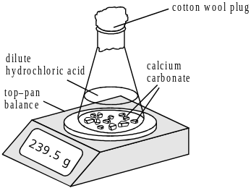
The students recorded the mass at known times after the start. Their results are shown on the graph.
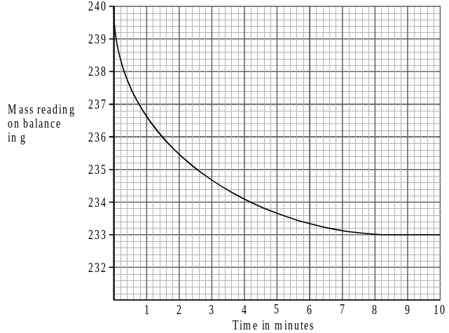
(i) How does the mass of the reaction mixture change during the reaction? [1]
(ii) Explain why this change in mass takes place. [2]
(iii) Use the graph to find the reading on the balance at the end of this reaction. [1]

(b) The experiment was repeated using the same masses of acid and calcium carbonate as in the first experiment but using powdered calcium carbonate instead of lumps.
i) How did the rate of reaction change when powder was used instead of lumps? [1]
ii) Draw a sketch of the graphical results you would expect for this experiment. Include the results from the first experiment from part a). [2]
(c) Suggest THREE ways of increasing the rate of reaction of a finely powdered solid with an acid.
[3]

3. Marble chips react with hydrochloric acid according to the equation:
CaCO3(s) + 2HCl(aq) → CaCl2(s) + H2O(l) + CO2(g)

- Sketch a graph of how you would expect the volume of carbon dioxide to vary with time, assuming there is a large excess of medium-sized marble chips, and that the reaction reaches completion. [3]

(ii) On the same graph, sketch a curve to show what happens if you repeat the experiment with the same amount of marble, but this time using small chips [2]

(iii) On the same graph, sketch what will happen if you repeat the experiment again using the same mass of large marble chips. [2]

With reference to your graph, explain in terms of collisions:

(iv) Why the curve in (i) has the shape it does. [4]

(v) Why the curve in (ii) is different from that in (i). [2]

(vi) Why curve (iii) is different. [2]

(vii) Draw a labelled diagram of the apparatus that could have been used to generate the results
for the graphs you plotted in parts i) to iii). [3]

Rates 2 - Concentration
Complete Chemistry for IGCSE - pg 148-149 and 152-153 Total / 33

1. When an acid is added to bleach, chlorine gas is produced.
The diagram shows apparatus used to measure the volume of chlorine gas produced.
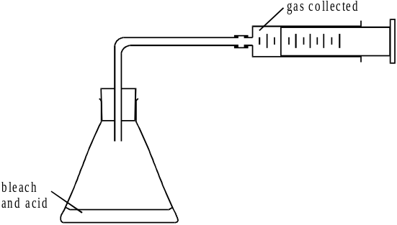
The reaction was carried out using an excess of acid (10 cm³). The chlorine was collected and its volume recorded every half minute. The results are shown in the table.
time (minutes) | 0.0 | 0.5 | 1.0 | 1.5 | 2.0 | 2.5
volume of chlorine (cm³) | 0 | 10 | 17 | 22 | 26 | 29

(a) (i) Draw a graph of these results on the grid.
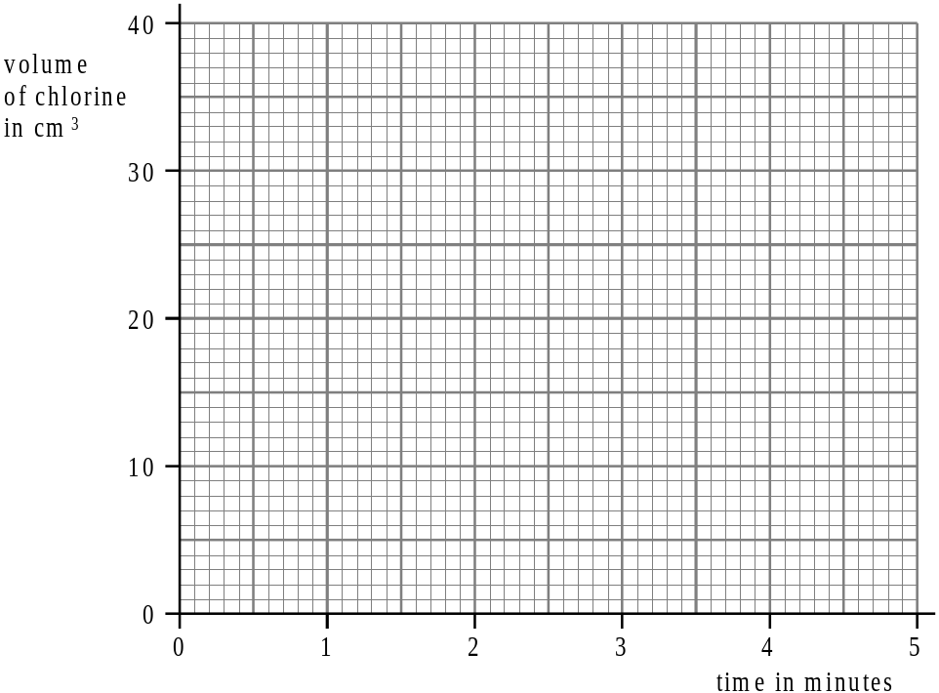
[3]
(ii) The reaction had not finished after 2.5 minutes. Explain how you know this is true. [1]
(iii) The reaction finished in less than 5 minutes. Continue your graph to show this.
Use your graph to estimate the total time for the reaction. [2]
(b) The reaction was repeated under the same conditions but using twice the concentration of acid.
Explain how, if at all, the rate of reaction would change compared to the first experiment. [3] [2]

2. The reaction between sodium thiosulphate solution (Na2S2O3) and dilute hydrochloric acid can be used to study the effect of concentration on the rate of the reaction below.

Na2S2O3(aq) + 2HCl(aq) → 2NaCl(aq) + H2O(l) + S(s) + SO2(g)
(Sodium thiosulphate)

When the reactants are mixed together a yellow precipitate of sulphur is produced.

Experiments were performed to measure the rate using various concentrations of sodium thiosulphate.

a) List the variables must be kept the same if the experiment is going to be fair? [3]

b) Describe two methods that could be used to measure the rate of reaction. [4]

The actual method used measured the time for the sulphur precipitate (solid) to fully appear.
The results for the experiment are shown below;

Conc of Na2S2O3 | Time for precipitate (solid) production (s) | Rate of reaction  (s⁻¹)
0.15 M | 43
0.12 M | 55
0.09 M | 66
0.06 M | 105
0.03 M | 243

c) Given that the rate can be found from the relationship, Rate = 1 / time, complete the result table.
[2]

d) Plot a graph of time for rate of reaction against concentration of Na2S2O3 . [4]

e) What happens to the rate as the concentration of Na2S2O3 is increased? [3]

f) Explain your answer to part e) in terms of the particles in the reaction. [4]

g) Comment on the results obtained, explaining where errors could possibly have occurred
and how they can be minimised. [4]

Rates 3 - Temperature
Complete Chemistry for IGCSE - pg149 and 152-153 Total / 30

1. An experiment is carried out to investigate how the rate of reaction of magnesium with
hydrochloric acid varies with temperature.
A 2 cm strip of magnesium ribbon is measured with a ruler and 50 cm³ of hydrochloric acid is
measured with a measuring cylinder.
The beaker of acid is heated to the required temperature using a Bunsen burner.
The beaker is placed on a heatproof mat and the magnesium strip added immediately.
The time taken for all of the magnesium to react is measured with a stopwatch.
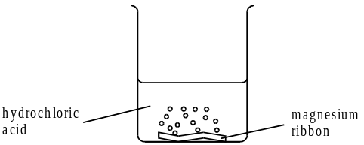

The results of the experiment are shown in the table.
temperature (°C) | reaction time (s)
20 | 58
30 | 42
40 | 30
50 | 23
(a) (i) Use the results to describe how the rate of reaction varies with temperature. [2]
(ii) Explain, in terms of particles, why the rate varies in this way. [3]
(iii) The reaction is exothermic. Explain why this affects the validity of the results. [2]
(b) Suggest two improvements in the experimental procedure indicated above, to improve the accuracy or validity of the results. [2]

2. The reaction between sodium thiosulphate solution (Na₂S₂O₃) and dilute nitric acid (HNO₃) can
be used to study the effect of temperature on reaction rate.
Na₂S₂O₃(aq) + 2HNO₃(aq) → 2NaNO₃(aq) + H₂O(l) + S(s) + SO₂(g)
a) Describe what would be observed when the reactants are mixed together. [2]
b) Describe two methods for following the rate of this reaction. [4]
Experiments were performed to measure the rate of reaction at various temperatures using 5 cm³
of 2.0 M nitric acid with 50 cm³ of 0.05 M Na₂S₂O_{3(aq)}.
The time taken for a cross to disappear was recorded.
The results are shown in the table below;
Temperature (ºC) | Time taken (sec) | 1 / time taken (sec⁻¹)
23 | 132
29 | 90
34 | 64
44 | 38
59 | 20
c) Complete the third column of data (1 / time taken). [2]
d) Which column in the table shows the rate of the reaction? [1]
e) Plot a graph of the rate of reaction against the temperature. [4]
f) What happens to the rate as the temperature of the reaction is increased? [2]
g) Explain your answer to question f) in terms of Kinetic Theory. [4]
h) Use your graph to show what happens to the rate when the temp is increased by 10ºC? [2]
Rates 4 – Curves and Catalysts
Complete Chemistry for IGCSE - pg152-155 Total / 30

1. The graph below shows how the volume of carbon dioxide produced varies against time
during reaction 1, which is a reaction between calcium carbonate and hydrochloric acid.
The calcium carbonate was in excess.
Sketch and label similar curves for reactions 2-7.

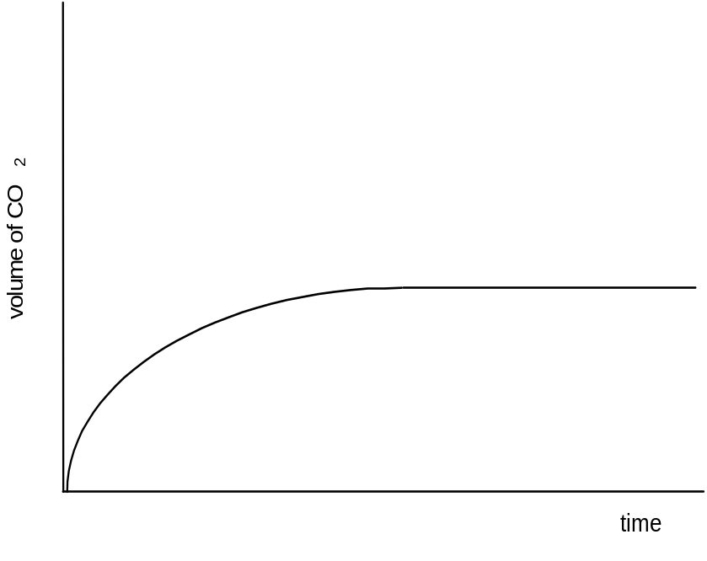
 | CaCO₃ | HCl concentration  (mol dm⁻³) | Volume HCl  (cm³) | Temperature  (°C)
1 | small | 2 | 100 | 20
2 | large | 2 | 100 | 20
3 | small | 2 | 200 | 20
4 | small | 4 | 100 | 20
5 | small | 2 | 100 | 30
6 | Small + catalyst | 2 | 100 | 20
7 | small | 1 | 200 | 20
[12]

2. Hydrogen peroxide (H₂O₂) decomposes slowly at room temperature to form oxygen and water.
(a) Write a balanced equation for this reaction. [2]
(b) Manganese(IV) oxide acts as a catalyst for this reaction.
i) What is a catalyst? [1]
ii) Describe how a catalyst is able to speed up a reaction in terms of collision theory. [3]
  - Draw an energy profile diagram showing how a catalyst is able to speed up a reaction. [3]

Andy added 1.0 g of manganese(IV) oxide to 20 cm³ of hydrogen peroxide solution at room
temperature. He measured the total volume of oxygen given off at one minute intervals.
His results are shown in the table.
Time (minutes) | 0 | 1 | 2 | 3 | 4 | 5
Total volume of oxygen (cm³) | 0 | 31 | 41 | 44 | 48 | 48

(c) Draw a graph of total volume of oxygen produced against time.
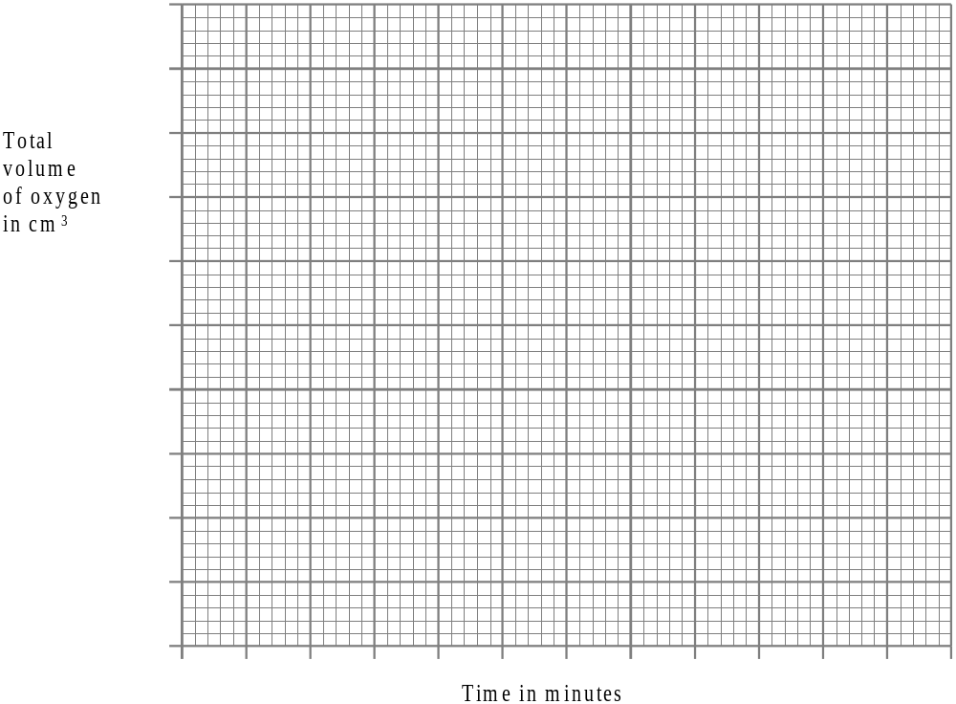 [3]

(d) At the end of the experiment Andy filtered off the oxide.
What mass of oxide would you expect to be left? Explain your answer. [2]

Andy then added 1.0 g of a different oxide to a fresh 20 cm³ sample of hydrogen peroxide
solution at the same temperature.
Again he measured the volume of oxygen produced at one minute intervals.
From his results he concluded that this different oxide was a better catalyst than
manganese(IV) oxide.

(e) Add a line to your graph to show results which would support this conclusion.
Label this new line “Oxide”. [2]

(f) Suggest why the different oxide is a better catalyst for the decomposition of hydrogen peroxide. [2]

Equilibria and The Haber Process
Complete Chemistry for IGCSE - pg 166-169 and pg 216-217 Total / 35

1) What would happen to the amount of products formed in the following equilibrium in the following circumstances (explain your answers)? The forward reaction is endothermic.
CH₄(g) + H₂O(g) CO(g) + 3 H₂(g)
a) What would happen, and why, if the temperature was increased? [3]
b) What would happen, and why, if the pressure was increased? [3]
c) What would happen, and why, if more steam was added? [3]

2) Yellow chromate ions are in equilibrium with orange chromate ions.
2CrO₄²⁻(aq) + 2H⁺(aq) Cr₂O₇²⁻(aq) + H₂O(l)
yellow acid orange
a) What would happen, and why, if acid was added to a yellow solution of chromate ions? [3]
b) What would happen and why if alkali was added to a yellow solution of chromate ions? [3]

3) Ammonia is manufactured using the Haber process; N_{2(g)} + 3H_{2(g)} 2NH_{3(g)}
The graph below shows how the amount of ammonia produced varies with the temperature and pressure that the reaction is carried out at.
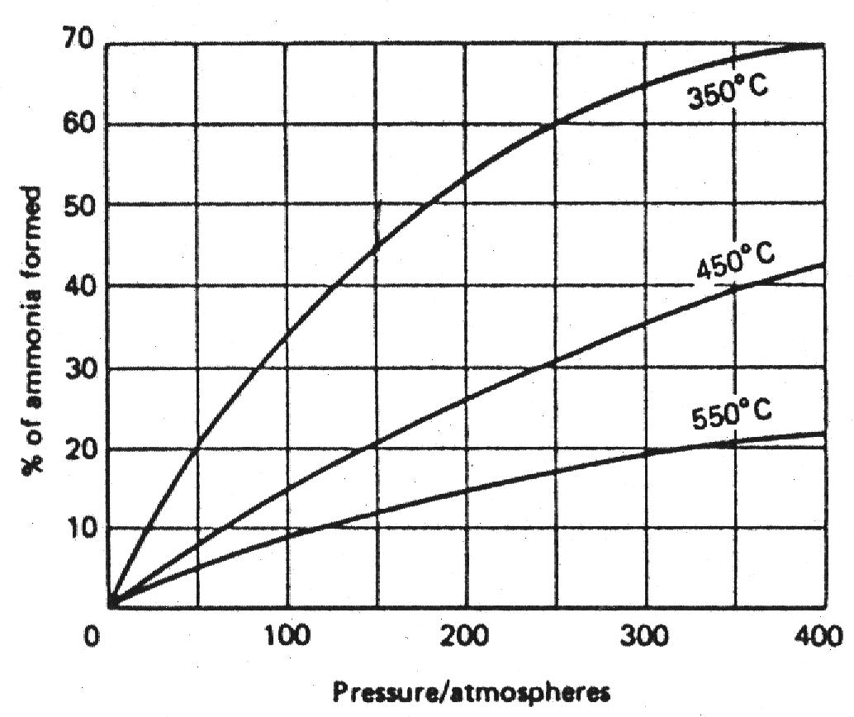
a) What is the effect of increasing pressure (if the temperature is kept constant)? [1]
b) What is the effect of increasing temperature (if the pressure is kept constant)? [1]
c) What conditions give the best yield of ammonia? [2]
d) What are the actual conditions used in the Haber process? [2]
e) Explain why the conditions in part d) are chosen. [2]
f) Nitrogen and hydrogen are needed to make ammonia.
What raw materials are needed to produce the nitrogen and hydrogen used? [3]
g) Once made the ammonia is transported as a liquid. Explain why. [2]

4) Methanol is manufactured from carbon monoxide and hydrogen using similar conditions to those used in the manufacture of ammonia by the Haber process.
The equation for the manufacture of methanol is
CO(g) + 2H2(g) CH3OH(g)
This reaction is exothermic.
The reaction conditions are a pressure of 200 atm and a temperature of 400 °C.
(a) State two advantages of using a pressure higher than 200 atm. [2]
(b) (i) State one advantage of using a temperature lower than 400 °C. Explain your answer. [3]
(ii) State one disadvantage of using a temperature lower than 400 °C. Explain your answer. [2]
Making Fertilisers

Complete Chemistry for IGCSE - pg 214-219 Total / 35

1 a) Why do we use fertilisers? [1]
b) What are N P K fertilisers? [3]
c) Crops grown in a heavy clay soil do not need a potassium fertiliser. Why? [2]
d) There are four main steps in the manufacture of the fertiliser ammonium nitrate.
1. The reaction of methane with steam to produce hydrogen.
2. The reaction of hydrogen and nitrogen to produce ammonia.
3. The oxidation of ammonia to produce nitric acid.
4. The reaction of ammonia with nitric acid to produce ammonium nitrate.
(i) Balance the equation for the reaction of methane with steam.
CH4 + H2O → H2 + CO2 [1]
(ii) Suggest the source of nitrogen for step 2. [1]
(iii) Write the balanced equation, including state symbols, for the reaction in step 2. [3]
(iv) Ammonia was first made in step 2 by this reaction using a pressure of 25 atmospheres.
Modem chemical plants use pressures of 200 atmospheres or more.
State two advantages of using a higher pressure for this reaction.
Give a reason to support each of your answers. [4]
(v) Write a balanced symbol equation for step 4. [2]
(vi) What type of reaction is involved in step 4? [1]
(vii) The fertiliser ammonium nitrate is very soluble in water.
Describe the advantages and disadvantages of this. [4]
e) Sulphuric acid is used to make the fertiliser ammonium sulphate, (NH4)2SO4.
2NH3 + H2SO4 → (NH4)2SO4
(i) Calculate the relative formula mass of ammonium sulphate. [1]
(ii) Calculate the maximum mass of ammonium sulphate that could be formed from 100 kg of ammonia. [3]

2. Three common nitrogen fertilisers are;
ammonium phosphate (NH₄)₃PO₄
ammonium chloride NH₄Cl
dimethyl urea CO(N{CH₃}₂)₂
For each source of nitrogen give;
a) the mass on one mole of the compound [3]
b) the % by mass of nitrogen in the compound [3]
c) the mass of compound needed to supply 4 kg of nitrogen atoms. [3]

End of Topic Checklist – Acids, Bases, Salts and Neutralisation
You will be assessed on your ability to;
 | Help!! | OK | Bring it on!
Describe the use of the indicators litmus, phenolphthalein and methyl orange to distinguish between acidic and alkaline solutions.
Understand how the pH scale, from 0-14, can be used to classify solutions as strongly acidic, weakly acidic, neutral, weakly alkaline or strongly alkaline.
Describe the use of universal indicator to measure the approximate pH value of a solution.

Define acids as sources of hydrogen ions, H⁺, and alkalis as sources of hydroxide ions, OH⁻.

Predict the products of reactions between dilute hydrochloric, nitric and sulfuric acids; and metals, metal oxides and metal carbonates (excluding the reactions between nitric acid and metals).
Describe the reactions of dilute hydrochloric and dilute sulfuric acids with magnesium, aluminium, zinc and iron.
Describe how to carry out acid-alkali titrations.

Carry out mole calculations using volumes and molar concentrations.

End of Topic Checklist – Preparing and Analyzing Salts
You will be assessed on your ability to;
 | Help!! | OK | Bring it on!
Describe how to prepare soluble salts from acids.

Describe how to prepare insoluble salts using precipitation reactions.

Recall the general rules for predicting the solubility of salts in water:
- all common sodium, potassium and ammonium salts are soluble
- all nitrates are soluble
- common chlorides are soluble, except silver chloride
- common sulphates are soluble, except those of barium and calcium
- common carbonates are insoluble, except those of sodium, potassium and ammonium
Describe simple tests for the gases;
- hydrogen
- oxygen
- carbon dioxide
- ammonia
- chlorine
Describe simple tests for the cations;
- Li⁺ , Na⁺, K⁺, Ca²⁺ using flame tests.
Describe simple tests for the cations;
- NH₄⁺ using sodium hydroxide solution and identifying the ammonia evolved.
Describe simple tests for the cations;
- Cu²⁺, Fe²⁺ and Fe³⁺ using sodium hydroxide solution.
Describe simple tests for the anions;
- Cl-, Br- and I-, using dilute nitric acid and silver nitrate solution
Describe simple tests for the anions;
- SO₄²⁻, using dilute hydrochloric acid and barium chloride solution
Describe simple tests for the anions;
- CO₃²⁻, using dilute hydrochloric acid and identifying the carbon dioxide evolved
End of Topic Checklist – Energetics
You will be assessed on your ability to;
 | Help!! | OK | Bring it on!
Recall that chemical reactions in which heat energy is given out are described as exothermic and those in which heat energy is taken in are endothermic.
Describe simple calorimetry experiments for reactions, such as combustion, displacement, dissolving and neutralisation in which heat energy changes can be calculated from measured temp changes.
Understand the use of ΔH to represent molar enthalpy change for exothermic and endothermic reactions.
Represent exothermic and endothermic reactions on a simple energy level diagram.

Recall that the breaking of bonds is endothermic and that the making of bonds is exothermic.

Use average bond energies.

End of Topic Checklist – Rates of Reaction
 | Help!! | OK | Bring it on!
Describe experiments to investigate the effects of changes in surface area of a solid, concentration of solutions, temperature and the use of a catalyst on the rate of a reaction.
Describe the effects of changes in surface area of a solid, concentration of solutions, pressure of gases, temperature and the use of a catalyst on the rate of a reaction.
Understand the term ‘activation energy’ and represent it on a reaction profile.

Explain the effects of changes in surface area of a solid, concentration of solutions, pressure of gases and temperature on the rate of a reaction in terms of particle collision theory.
Understand that a catalyst speeds up a reaction by providing an alternative pathway with lower activation energy.

End of Topic Checklist – Equilibria and Industrial Chemistry
 | Help!! | OK | Bring it on!
Recall that some reactions are reversible and are indicated by the symbol in equations

Describe reversible reactions such as the dehydration of hydrated copper(II) sulphate and the effect of heat on ammonium chloride.
Understand the concept of dynamic equilibrium.

Predict the effects of changing the pressure and temperature on the equilibrium position in reversible reactions.
Recall that nitrogen from air, and hydrogen from natural gas or the cracking of hydrocarbons, are used in the manufacture of ammonia.
Describe the manufacture of ammonia by the Haber process, including the essential conditions:
temperature = about 450 °C pressure = about 200 atmospheres an iron catalyst.
Understand how the cooling of the reaction mixture liquifies the ammonia produced and allows the unused hydrogen and nitrogen to be recirculated.
Recall the use of ammonia in the manufacture of nitric acid and fertilisers.

Chemistry Self Assessment Sheet - Effort

1 = CONSISTENTLY OUTSTANDING IN ALL AREAS;
2 = GOOD IN ALL AREAS – Beyond the normal ‘call of duty’;
3 = SATISFACTORY IN ALL AREAS – Meets the minimum requirements;
4 = POOR or INCONSISTENT IN MOST AREAS – Needs urgent attention.

 | Acids, Bases, Salts | Preparing + Analysing salts | Energetics | Rates of Reaction | Equilibria
Deadlines and Organisation
Is your homework always handed in on time, complete and to the best of your ability?
Do you bring the correct books to lessons?
Behaviour
Are you fully attentive during lessons and not distracting to or distracted by others?

Class participation
Do you think beyond the subject matter taught and raise questions in lessons and ask for help when you need it?

Assessed Work
Have you given your written work the time and effort it merits
and presented it in an orderly, logical manner?
End of Unit Test Result
(% and Grade)

